Program source code with explanation.

## Imports and Current Time Setup

Import necessary modules like time, datetime, and sys and set up the current date.

## Controller ID List

Create a list that contains the controller ID and password pairs for the login verification.

## Initial Creation of Files

Create the initial PPE and Supplier txt files. It should be executed once only.

## Login Function

Define a login function that allows 3 login attempts, checks entered ID and password with the “controller_ID_List”, grants or denies access and implement a 60 seconds delay after 3 login attempts.

## Main Page Function

Display the main menu for the users to choose an action or exit the program.

## Inventory Access Function

Access and display inventory details from the 'PPE.txt' file based on user selection. The function allows the user to select an item and view its details or return to the main page.

## Hospital Access Function

Prompt the user to select a hospital to access or return to the main page. This function is designed to handle hospital-specific inventory or actions.

## Hospital Inventory Function

Access and display inventory details for specific hospitals from the 'hospital.txt' file. It allows the user to select a hospital and view its inventory details.

## Receive Inventory Function

Updates inventory records by prompting the user for details on received items, logging the receipt, and adjusting the quantities in the inventory file accordingly.

## Distribution Function

Prompts users to choose the hospital and items to be distributed, number of boxes of items to be distributed

## Distribution Record Checking Function

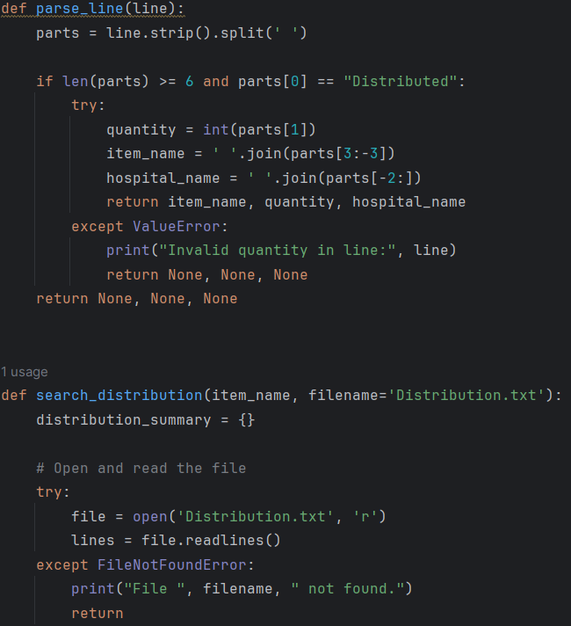

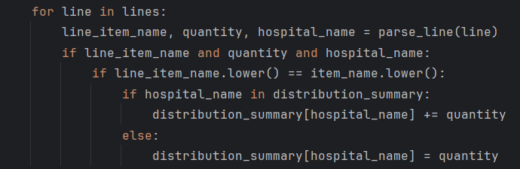

parse_line

Parses a line of text from the distribution file to extract the quantity, item name, and hospital name if the line indicates a distribution record.

search_distribution

Searches for distribution records of a specific item from Distribution.txt and summarizes the quantities distributed to different hospitals. It prints the distribution summary with hospital codes and total quantities.

## Supplier Inventory Checking Function

Provides information about which companies supply specific types of inventory items and offers options to check suppliers for different items and allows returning to the main menu.

## Inventory Tracking Function

Provides options to check the total quantity of inventory or to identify inventory items that have less than 25 boxes remaining. Reads inventory data from PPE.txt and prints relevant information based on user input.

## Monthly Receive Report Generation Function

parse_supply_line

Parses a line from Received.txt to extract the quantity, item, company, and date of supply. It returns these values if the parsing is successful.

generate_receive_report

Prompts the user for a year and month, then reads and filters supply data from Received.txt based on the specified date. It generates a report summarizing the quantity of supplies received from different companies and prints the results.

## Monthly Distribution Report Generation Function

parse_supply_line_distribution

Parses a line from Distribution.txt to extract the quantity, item, hospital, and date of distribution. It returns these values if the parsing is successful.

generate_distribution_report

Prompts the user for a year and month, then reads and filters distribution data from Distribution.txt based on the specified date. It generates a report summarizing the quantity of supplies distributed to different hospitals and prints the results.

## Pickup Function

The pickup() function is a main menu handler that provides users with a menu-driven interface to perform various tasks related to inventory and distribution. It continuously presents options until the user selects a valid action or chooses to exit.

## Access Control System

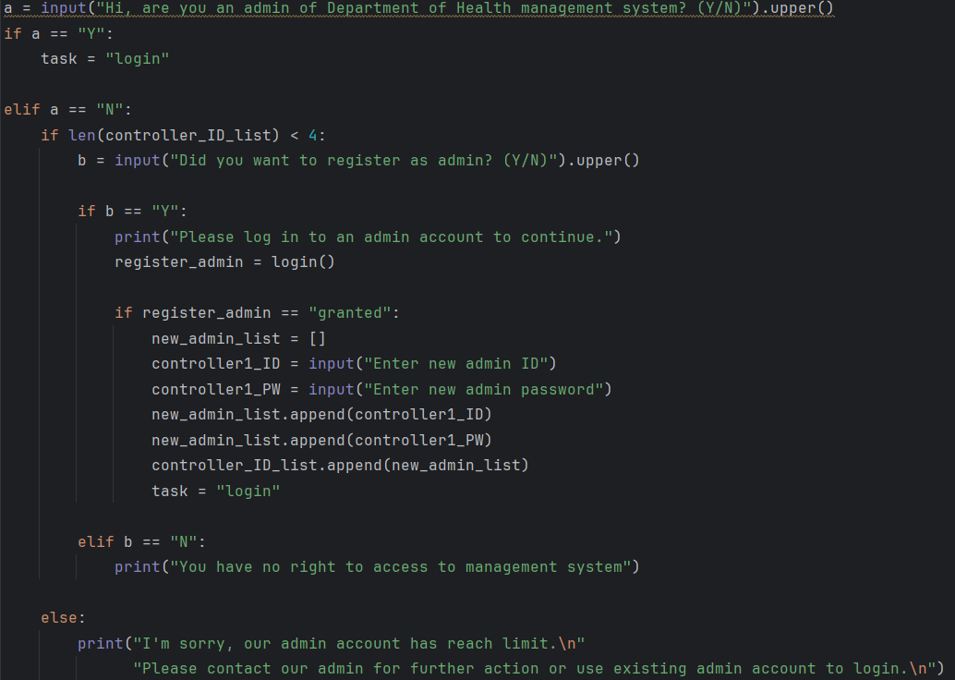

Provides interface for users to either log in, register as an admin or deny access if they are not an admin.